PRESS RELEASE

Wieland Thermal Solutions

Ulm, Oktober 2013

Safe, energy-efficient and hygienic:
Wieland heat exchanger copper tubes for drinking water heat pumps

Drinking water heat pumps with double-wall heat exchanger copper tubes from Wieland achieve peak COP values and already meet the EU Drinking Water Directive’s requirements taking effect from December 2013.

Quality requirements for drinking water are becoming increasingly stringent throughout the world. As from December 2013, the new limit of 10 micrograms per litre for the lead content in drinking water will take effect. In the USA, a uniform lead content for drinking-water fittings of maximum 0.25 per cent, relating to the weighted average of surfaces in contact with water, will become effective as from the beginning of 2014. The WRKS safety heat exchangers with double-wall GEWA-safe finned tubes from Wieland Thermal Solutions already meet these requirements, as both the finned double-wall copper tube coil and the connecting flanges consist of drinking water-compliant materials which fulfil the mentioned legal requirements in the EU and the USA. For example, in Germany the materials, of which the Wieland WRKS heat exchangers are made, are already included in the Federal Environment Agency’s list of approved materials and are, therefore, classified as “metallic materials suitable for contact with drinking water” in conformance with the EU Drinking Water Directive as from December 2013. In addition to their excellent hygienic suitability, WRKS heat exchangers provide a high level of operating safety thanks to double-wall tubes. The finned tubes lead to an increase in the heat pump’s energy efficiency with COP values of 3.0 and more.

Drinking water heat pumps supply households energy-efficiently with hot water. In order to ensure the protection of drinking water during heating, clear requirements are in place from the European Union (EU Directive 98/83/EC) and the national drinking water ordinances. Effective from 1 December 2013, these requirements will become considerably more restrictive in the EU due to the reduced limit value for lead of 10 micrograms per litre. The WRKS safety heat exchangers with GEWA-safe finned tubes from Wieland Thermal Solutions meet the requirements: In terms of hygienic suitability, both the connecting flanges made of the brass Z48 and the copper-tube coil already meet the legal requirements taking effect from 1 December 2013.

As regards the purity of drinking water, the WRKS heat exchanger from Wieland Thermals Solutions offers excellent protection. The use of double-wall finned tubes provides a safety space which, in the case of leakage, prevents contamination of the drinking water with oil contained in the refrigerant of the heat pump. Leaks can thus be detected in time and the heat pump can be operated safely until the arrival of the service engineer.

The finned tubes and the excellent thermal conductivity of copper lead to an increase in the heat pump’s energy efficiency, thus ensuring a resource-efficient operation. As a result of direct condensation in the hot water tank, the compact WRKS heat exchanger enables almost loss-free energy transfer. The energy efficiency of the system is also increased by the fact that the double-tube solution makes a second heating circuit unnecessary. The COP values thus achieved of 3.0 and more are among the best energy efficiency values in the industry.

More information at www.wieland-thermalsolutions.de

Photos:
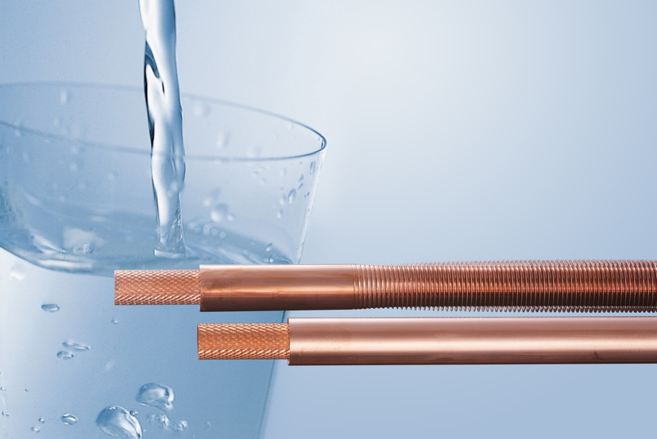
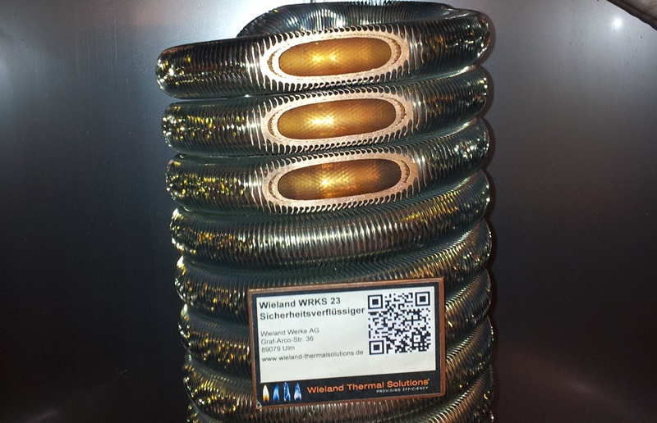
Safe drinking-water heating: tinned double-wall “WRKS 23” safety heat exchanger from the Dutch stainless steel hot water tank manufacturer DEJONG

“GEWA-safe”: safe drinking water heating with the Wieland Thermal Solutions safety tube

Photos for download at http://amid-pr.press-n-relations.com
Search word: “Thermal Solutions”

Background information

Wieland Thermal Solutions is a brand of the Wieland Group and offers a wide range of industry- as well as customer-specific thermal engineering solutions based on in-house research and development. Wieland Thermal Solutions addresses the market segments heating, air conditioning and refrigeration, process technology as well as mechanical and plant engineering. High-quality Wieland products such as inner-grooved and outer-finned tubes, heat exchangers and plain tubes enable the realisation of sophisticated technical solutions for industrial applications. In addition to copper and copper alloys, materials such as aluminium, steel, stainless steel and titanium are used for these products.

The Wieland Group is one of the world’s leading manufacturers of semi-finished and special products in copper and copper alloys such as strip, sheet, tube, rod, wire and sections as well as slide bearings, finned tubes and heat exchangers. The Wieland Group has more than 30 manufacturing companies, slitting centres and trading companies in Europe, Asia, South Africa and the USA. The Wieland Group achieved a turnover of 2,875 million euros in the fiscal year 2011/2012 with sales quantities of 433,000 tons. Wieland’s global workforce is approx. 6,500 strong of which over 4,000 are employed in Germany.
Further information:  Wieland-Werke AG  Karin Maier, Public Relations  Graf-Arco-Straße 36 - 89079 Ulm, Germany  Phone: 0049 731-944-2663  Fax: 0049 731-944-42663  karin.maier@wieland.de  www.wieland.de | Public relations:  Press’n’Relations GmbH  Bruno Lukas  Magirusstraße 33 - 89077 Ulm, Germany  Phone: 0049 731-9628717  Fax: 0049 731-9628797  blu@press-n-relations.de  www.press-n-relations.de

