Heidenheim, 19th September 2008

High-Tech from Heidenheim: Lohse Products Successful Worldwide
Significant economic factor for the region – manufacture exclusively in Germany

The Heidenheim machine building and valve specialist Lohse has been focussing on “Made in Germany” with success for 100 years. Starting with locksmith work, the traditional operation in paper and waste management and in the air technology industry has developed into a significant manufacturer for machines, plants, apparatus and valves. The family firm consists of two companies: Whilst Martin Lohse GmbH focuses on valves, Maschinenbau Lohse GmbH manufactures an array of different machines and apparatus. For instance, as the only renowned German producer the highly specialised niche manufacturer offers feeders for paper production with two-part housing and is a technology leader in this field. Parallel to the paper and disposal industries Lohse also focuses on the chemical industry and the air technology industry. Thus, Lohse develops power station components, climate chambers and axial ventilators for example. Wind tunnels, designed by Howden and produced by Lohse are used amongst other things to optimise the aerodynamics and acoustics of cars and racing cars. In addition to international renown as a special supplier Lohse has traditionally been a significant economic factor in the Heidenheim/Ostwürttemberg region. With 164 employees and a turnover of 16.5 million euros in the 2007 financial year, Lohse contributes substantially to regional added value with its two companies as one of the top-1o firms. Since the firm was founded it has focussed on Germany as a location and, thus on excellent German engineering know-how and the highest product quality. The result are tailored solutions based on top products, which are competitive across the globe thanks to “Made in Heidenheim”.

Future Markets: Environmental Technology and Renewable Energies
Based on the well-founded know-how in plant building and in waste management, Lohse has been involved for more than two decades in the future-oriented industries of environmental technology and renewable energies. In building plants to extract biogas from biological waste the Heidenheim specialist was one of the pioneers on the market at the end of the 1980s. Lohse still offers solutions to conquer the effects of climate change today: the company is currently developing an energy-efficient plant for solar-powered seawater desalinisation in cooperation with the Fraunhofer-Technologie-Entwicklungsgruppe TEG. The plant can be used to produce drinking water in dry and hot regions that have water shortages, for example in southern Europe on the Mediterranean where a trial plant is already in place.

Artistic Locksmith: The economic base of the early years
The starting point for Lohse business activities 100 years ago was the founding of an artistic locksmith’s shop by Georg Bauder in the Heidenheim “in der Erchen” building area. With the production of spiral staircases the company occupied a market gap at the start of the 20th century and expanded rapidly. The change from locksmith work to steel construction from the 1930s onwards switched direction to the current production programme.

Entry into Paper Technology
Aside from the general economic downturn during the world economic crisis and the war years, Lohse has been able to expand its business activity continually up to the present day. With entry into paper technology at the start of the 1950s, Lohse laid the foundation for a consistent new technological direction. This step also led to entry into valve building and to setting up the site at Heidenheim-Oggenhausen. After moving valve construction to Oggenhausen, Lohse completed the final collation of all operational activities at the new location in 1980.

Know-How in Metal Processing, Combined with the Latest Production Methods
Today, Lohse manufactures a broad range of top products in a production space of 10,000 square metres in Heidenheim-Oggenhausen with a total of 164 employees. In addition to the production set-ups Lohse has massively expanded quality assurance over the last few years. Developments include an in-house materials lab, which is equipped with x-ray and macrophotographic plants. Thanks to decades of know-how in materials science and metal processing and the latest production methods, Lohse is also in a position today to realise particularly complex constructions, for example for plant and power station building.

Photos:

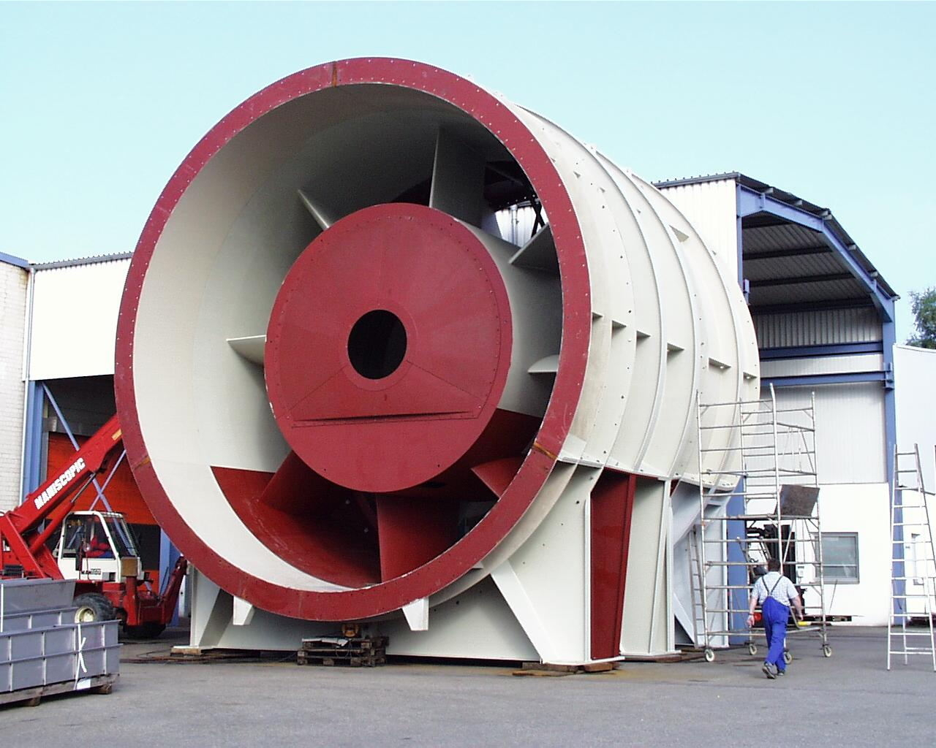
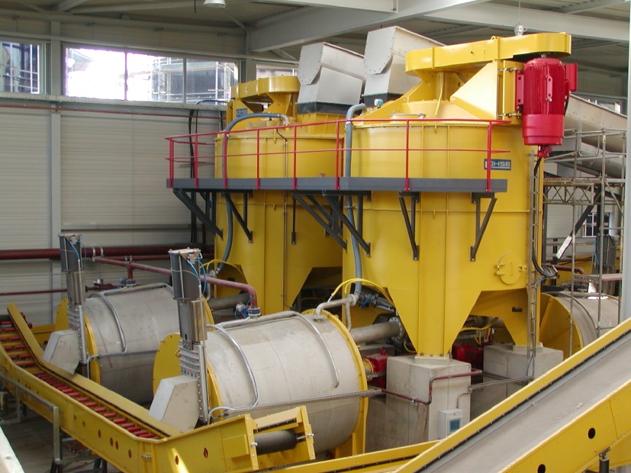

Wind tunnel production for Howden
Waste recycling plant

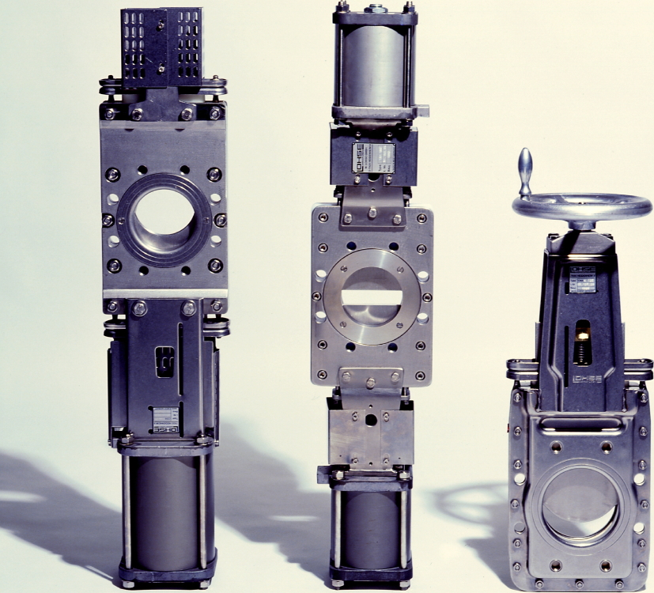
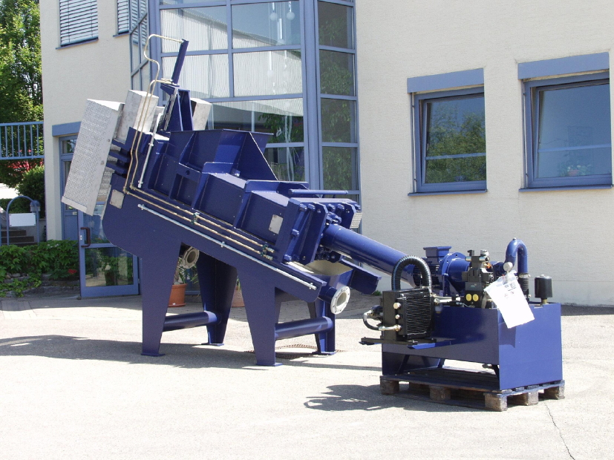

Valves (Lohse COMPACT range)
Reject presses

Photos can be downloaded at www.press-n-relations.de.

You can get other images on request from Bruno Lukas, Press’n’Relations GmbH, Tel.: +49 731 962 87 17, e-mail: blu@press-n-relations.de

Other information:  Martin Lohse GmbH  Christine Cordes  Unteres Paradies 63 – 89522 Heidenheim-Oggenhausen  Tel. +49 7321 755 55 – Fax: +49 7321 755 97  christine.cordes@lohse-gmbh.de - www.lohse-gmbh.de | Press and Public Relations:  Press’n’Relations GmbH  Bruno Lukas  Magirusstr. 33 - D-89077 Ulm  Tel.: +49 731 962 87 17 - Fax: +49 731 / 962 87 97  blu@press-n-relations.de - www.press-n-relations.de
Martin Lohse GmbH
Dipl.-Wi.-Ing. Martin Lohse
Managing Director
Unteres Paradies 63 – 89522 Heidenheim-Oggenhausen
Tel. +49 7321 755 0 – Fax: +49 7321 755 99
martin.lohse@lohse-gmbh.de - www.lohse-gmbh.de
Maschinenbau Lohse GmbH
Dipl.-Ing. (FH) Dietmar Warnke
Managing Director
Unteres Paradies 63 – 89522 Heidenheim-Oggenhausen
Tel. +49 7321 755 0 – Fax: +49 7321 755 99
dietmar.warnke@lohse-gmbh.de - www.lohse-gmbh.de

